**Fr. Conceicao Rodrigues College of Engineering, Bandra (W)**

**TE Electronics & Computer Science (SEM IV)**

**Mini Project-1A Proposal Form**

**AY -2022 - 23**

# Name of the student(s) with roll numbers

* Piyush Ram Kasle (9132)
* Ronit Patange (9145)
* Hardik Raju Prajapati (9152)

2. **Title of the Mini Project:**

**“House Price Prediction”**

1. **Mini Project Category:**

|  |  |  |  |
| --- | --- | --- | --- |
| **Research** |  | **Software** | √ |
| **Application** | √ | **Hardware** |  |
| **Product** |  | **Software and Hardware** |  |

1. **Mini Project Area/ Problem Characteristics:**

|  |  |  |  |
| --- | --- | --- | --- |
| **Analog Circuits** |  | **Software Tools** | √ |
| **Digital Circuits** |  | **Mobile Application** |  |
| **Micro-Controller based circuits** |  | **DBMS/Data Structure Application** |  |
| **Basic Science/Engineering** |  | **Social/Environmental issues** |  |
| **Others (Please Specify)** | | |  |

**Mentor’s Signature**

**Background**   
Buying a house is a stressful thing. Buyers are generally not aware of factors that influence house prices. Many problems are faced during buying a house. As earlier, House prices were determined by calculating the acquiring and selling price in a locality. Hence real estate agents are trusted with the communication between buyers and sellers as well as laying down a legal contract for the transfer. This just creates a middle man and increases the cost of houses. Therefore, the House Price prediction model is very essential in filling the information gap and improving Real Estate efficiency. With this model, we would be able to better predict the prices.

**5 A.** **Mini Project Abstract:**

Real estate is the least transparent industry in our ecosystem.  
House prices increase every year, so there is a need for a system to predict house prices in the future.  
Predicting House Prices with real factors.  
We aim to make evaluations based on every basic parameter that is considered while determining the price

**5 B. Project Objectives: [Clearly** State the desired objectives in Chosen problem.]

* To explore how predictive modelling can be applied in housing sale price prediction by analyzing the housing dataset and using machine learning.
* To determine the factors which affected the price of houses in recent years.
* To study which machine learning algorithm performs better and has the most accurate result in house price prediction.

### Technical Feasibility

c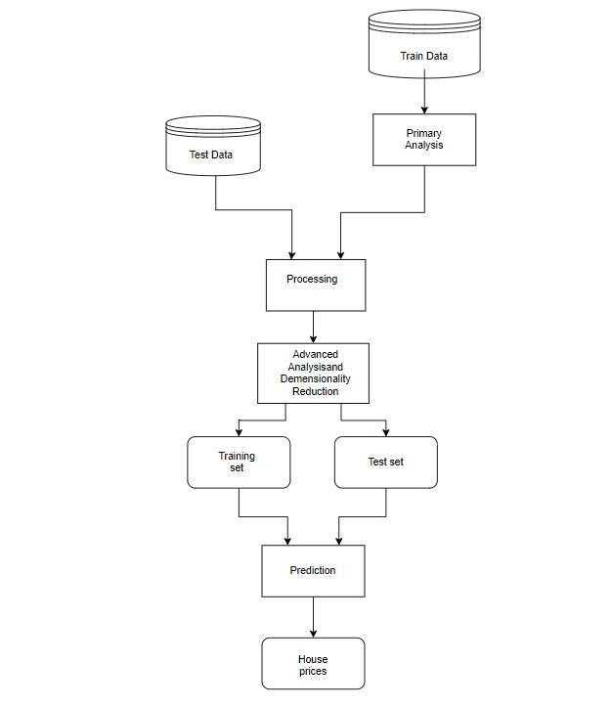

## System Requirements

### Software Requirements

Colaboratory (Google Colab)

1. **What is the Novelty / Innovation/ Social relevance of the proposed project?**

How predictive modeling can be applied in housing sale price prediction by analyzing the housing dataset and use machine learning models. Our project makes it easier for the user to read the data at any given time rather then always keeping track of it themselves. It also helps us as students with an opportunity to study and learn the use and wide use machine learning.

# References

1. Deep Learning Model for House Price Prediction Using Heterogeneous Data Analysis Along With Joint Self-Attention Mechanism: <https://ieeexplore.ieee.org/document/9395585>
2. Model “BANGALORE HOUSE PRICE PREDICTION MODEL”:

<https://www.researchgate.net/publication/354403038_Bangalore_House_Price_Prediction>

[4] Full Stack Development Code with Harry:

<https://www.youtube.com/watch?v=6mbwJ2xhgzM&list=PLu0W_9lII9agiCUZYRsvtGTXdxkzPyItg>

[5] Machine learning Code with harry:

https://www.youtube.com/watch?v=_u-PaJCpwiU&list=PLu0W_9lII9ai6fAMHp-acBmJONT7Y4BSG